https://staging4.guns2ammo.com/arizona-ccw-certification/

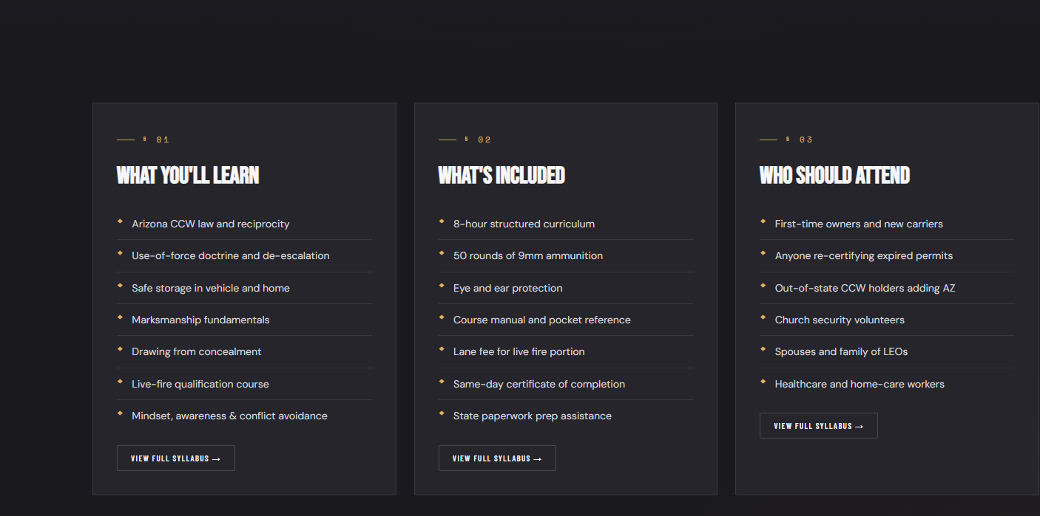
My course there is not shooting involved, if we want to have two different course one live fire and another on that I teach fine,
The price for the basic course with not live fire covers laws, regulations, training concepts but does not have a shooting component to it

If we want to build a second class and call it AZ CCW with live fire these things could apply. I would suggest that we do that, build two class 1 for the CCW without the live fire and one with.
The Non shooting class should be no more than 4 hours, while the shooting course should be no more than 5 hours. It takes about 3.5 hours to get through the laws and regulations and about .5 hours to get the paper work completed. Having the two classes would also allow us to fill another time slot. I would say we could do the live fire CCW course later in the day and hold people after normal business hours to complete the shooting component for example the non-live fire course has always started at 11:30 on Saturday morning, we could do the live fire later that day from say 3:30+5 hours and it would help fill the lanes. I would also suggest it be on a different day of the week, as weekends are busy times and we only have 6 lanes to shoot in, we could do this say Monday nights, as the range is slow on Monday and Tuesdays. But this would give us more utilizations of the facility and training components. We could also charge more for this. Making the Live fire course cost 149.99

